**Core Concepts - 13%**

1. **Architecture**

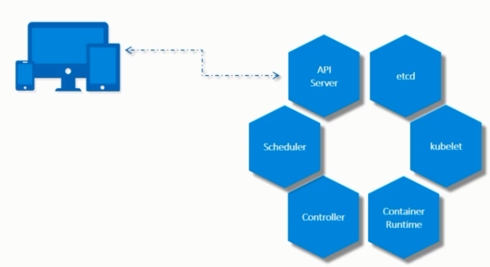

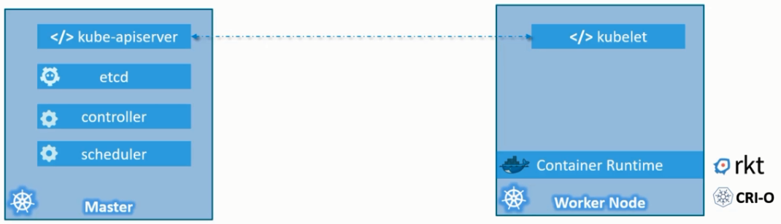

kubectl get nodes

kubectl cluster-info

1. **Pod:**

kubectl run --generator=run-pod/v1 nginx-pod --image=nginx

kubectl run --generator=run-pod/v1 nginx --image=nginx --port=8080　-l tier=db --env="DNS_DOMAIN=cluster" --dry-run -o yaml

kubectl run hazelcast --image=nginx --env="DNS_DOMAIN=cluster" --env="POD_NAMESPACE=default"

kubectl run hazelcast --image=nginx -l app=name,wf=ov

kubectl run --generator=run-pod/v1 nginx --image=nginx --port=8080 --command echo hi

kubectl create -f *.yaml

kubectl edit pod pod-name - edit already running pod // Need to verify

kubectl apply -f *.yaml

kubectl get pod <podname> -o wide

kubectl delete pod <podname>

kubectl describe pod <podname>

kubectl get pod podname –o yaml –export

kubectl set image pod/nginx nginx=nginx:1.7.1

kubectl exec podname -it bash **or** kubectl exec podname –it -- /bin/sh # get inside the pod

kubectl exec –it nginx – env # to display env variables

Pod deleted automatically when its completed ** use –restart=Never

1. **ReplicationController/ ReplicaSet**

kubectl run replicontrolr --generator=run/v1 --image=redis --replicas=2 --dry-run -o yaml // replicationcontroller

To generate file for replicaset -> generate deployment file and edit the file

kubectl create –f　 *.yaml

kubectl get replicationcontroller

kubectl get replicasets

kubectl delete replicaset <rp-name>

kubectl describe replicaset

kubectl edit replicaset replicaset-name - edit already running replicaset

1. **Scale**

-----

1. update replicas number in the file

kubectl replace -f file.yaml

2. kubectl scale --replicas=6 -f file.yaml

or

kubectl scale --replicas=6 replicaset replicaset-name

kubectl scale –replicas=3 –f filename.yaml

kubectl scale –current-replicas=1 –replicas=3 deployment/mydeploy

kubectl scale –replicas=3 rc/rc1 rc/rc2 rc/rc3 # Multiple replication controller update

<<this option wont update the replicas in the file>>

kubectl edit rs rs-name

1. **Deployment**

kubectl create -f *.yaml --record

kubectl run nginxx --image nginx

kubectl delete deployment dep-name

kubectl run --generator=deployment/v1beta1 nginx --image=nginx

Or

kubectl create deployment --image=nginx nginx

kubectl run --generator=deployment/v1beta1 nginx --image=nginx --dry-run -o yaml

Or

kubectl create deployment --image=nginx nginx --dry-run -o yaml

kubectl run --generator=deployment/v1beta1 nginx --image=nginx --dry-run --replicas=4 -o yaml

kubectl create deployment does not have a --replicas option. You could first create it and then scale it using the kubectl scale command.

kubectl run --generator=deployment/v1beta1 nginx --image=nginx --dry-run --replicas=4 -o yaml > nginx-deployment.yaml

**Service:**

kubectl create service clusterip ngservice --tcp=80:80 --dry-run -o yaml | after creating change the selector to required pod

kubectl create service nodeport nginx --tcp=80:8000 --node-port=30080 --dry-run -o yaml

kubectl expose deployment nginx --type=NodePort --port=80 --target-port=8000 --name=nginx-serv --dry-run -o yaml

kubectl expose deployment nginx –port=80 –target-port=8000

// need to check with docs

**namespace:**

kubectl get all --all-namespaces

kubectl exec -it app cat /log/app.log --namespace=elastic-stack

kubectl create namespace mynamespace

kubectl run nginx –image=nginx –n mynamespace

**ResourceQuota**: kubectl create quota myrq –hard=cpu=1,memory=1G,pods=2 –dry-run –o yaml

**Multipod container: 10%**

1. Many containers running in a single pod.

Labels and Slector

Kubectl get pods –selector app=App1

Kubectl get all –selector app=app1,tier=db

Annotations:

Annotations under metadata is to mention build number, contact details, build version etc

Rollout

Kubectl rollout status deployment/my-app-deployment

Kubectl rollout history deployment/my-app-deployment

When creating deployment , following steps happen

1. New rollout
2. New revision

After changing deplymnt file , >>> kubectl apply –f deploy-file

Kubectl set image deployment/mydeploy nginx=nginx:1.9.1

Strategy -> Recreate and Rolling update / can be viewd from the below command

Kubectl describe deployment mydeploy

Rollback

Kubectl rollout undo deployment/mydeploy

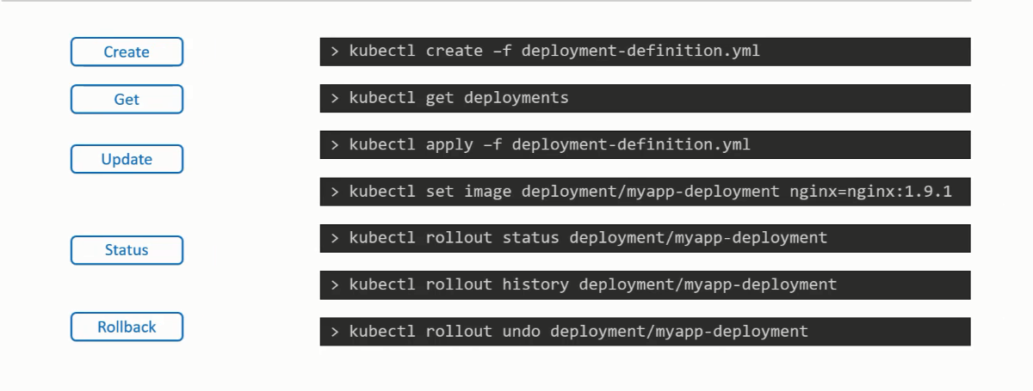

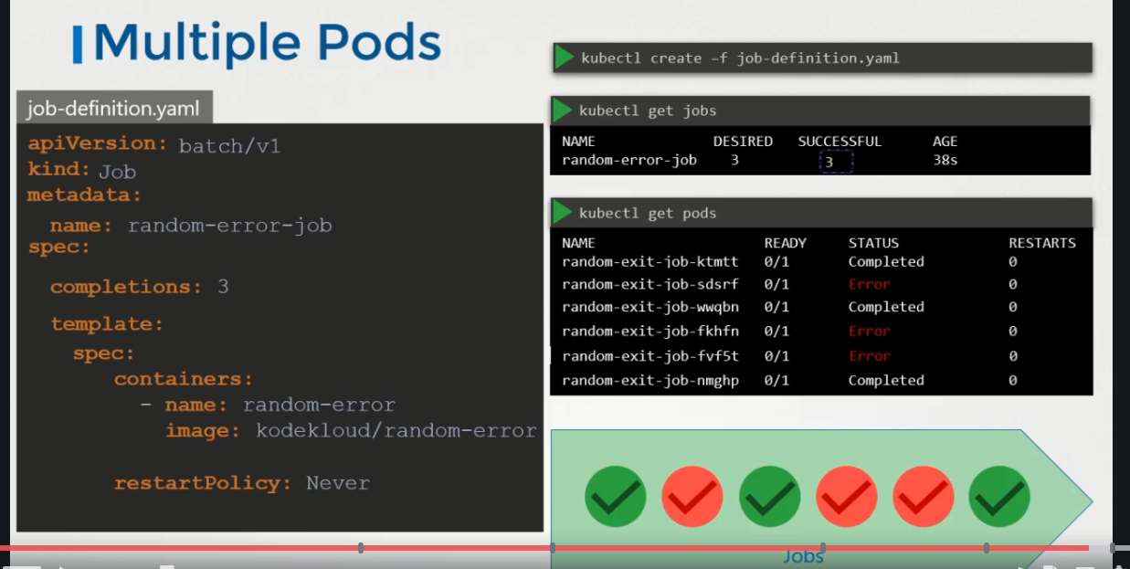

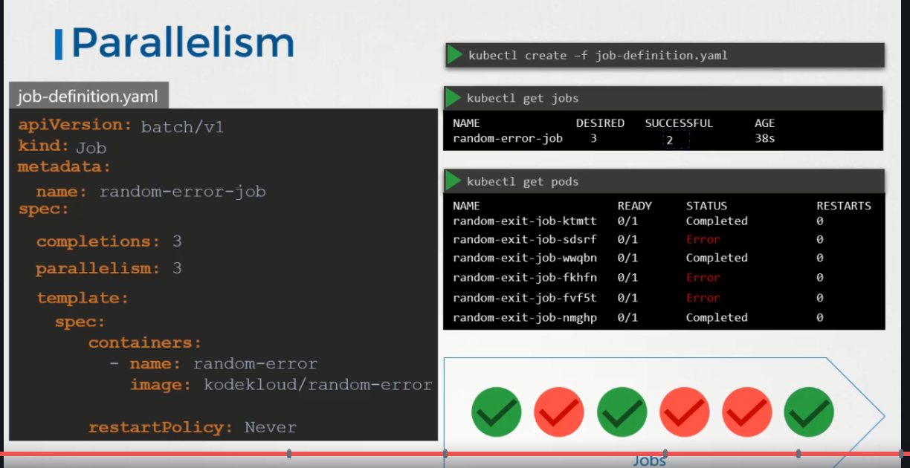

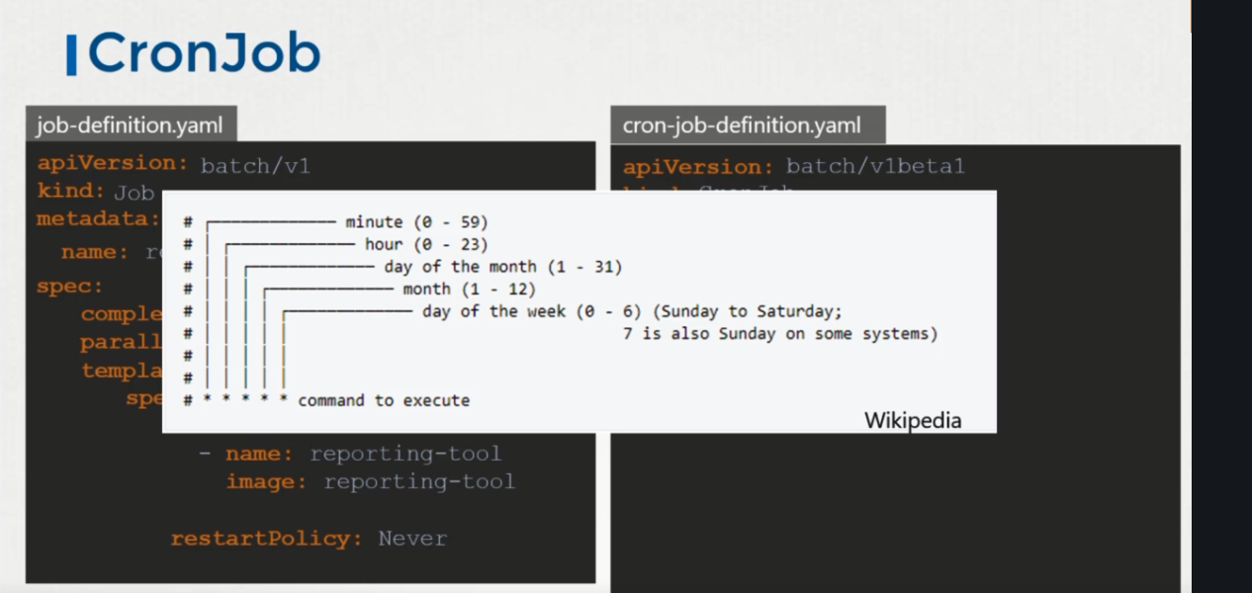

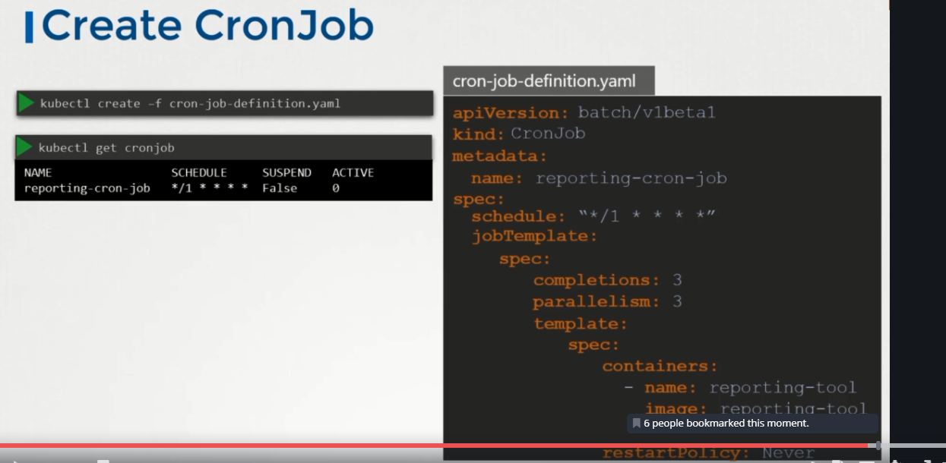

**Configurations**

**Command and arguments**

Docker commands:

Docker containers only lives as long as process running.

Once process inside container stops,the container go to exited state

Inside Docker file -> CMD[] it runs when the container starts

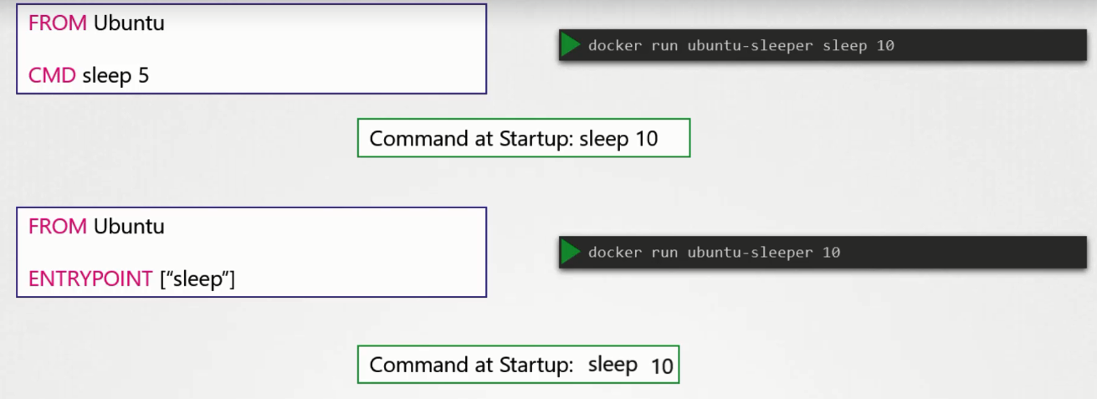

Command line arg over rides the command in the file. But if we use Entry point it appends the command and argument from the terminal

If user not sending 10 as arguments, then it ll fail at the startup. So inoder to give default value use CMD .

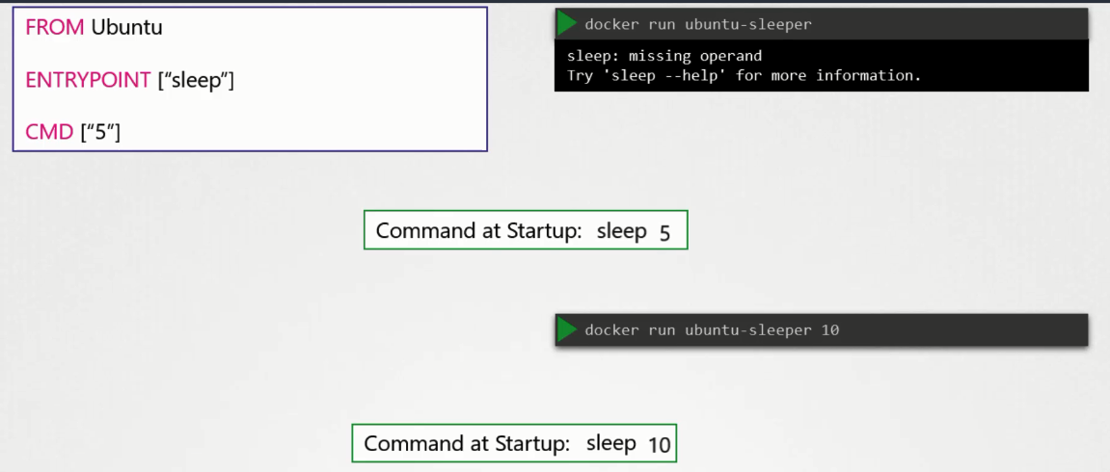

Use –entry-point when running docker command to over ride the entry point command.

**K8s Command and arguments**

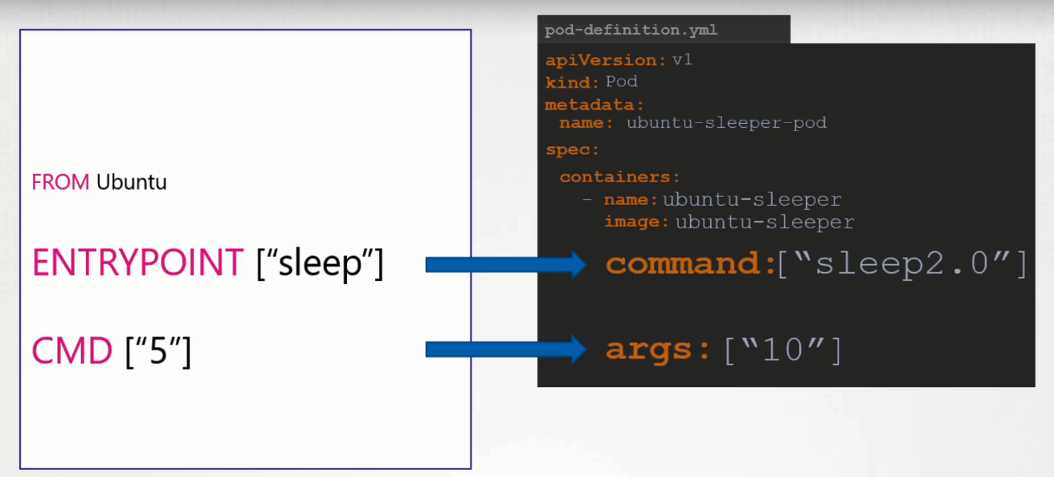

Over ride the Entry point command in the docker file 🡪 use command in k8s

Override the default CMD in docker file 🡪 use args in k8s

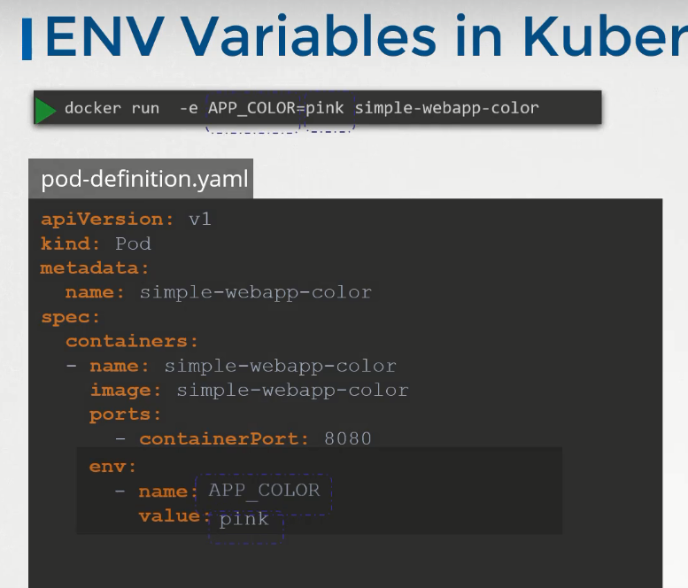

kubectl run --generator=run-pod/v1 nginx --image=nginx --port=8080　-l tier=db --env="DNS_DOMAIN=cluster" --dry-run -o yaml

**ConfigMaps**

When we have lot of pod files and difficult to manage environmental variable details. So Env variables can be taken out of the pod definition file and put it in a separate file called configmaps. Config maps are key value pair in k8s.

Kubectl create configmap app-config –from-literal=Name=ov --from-literal=Hname=karthi

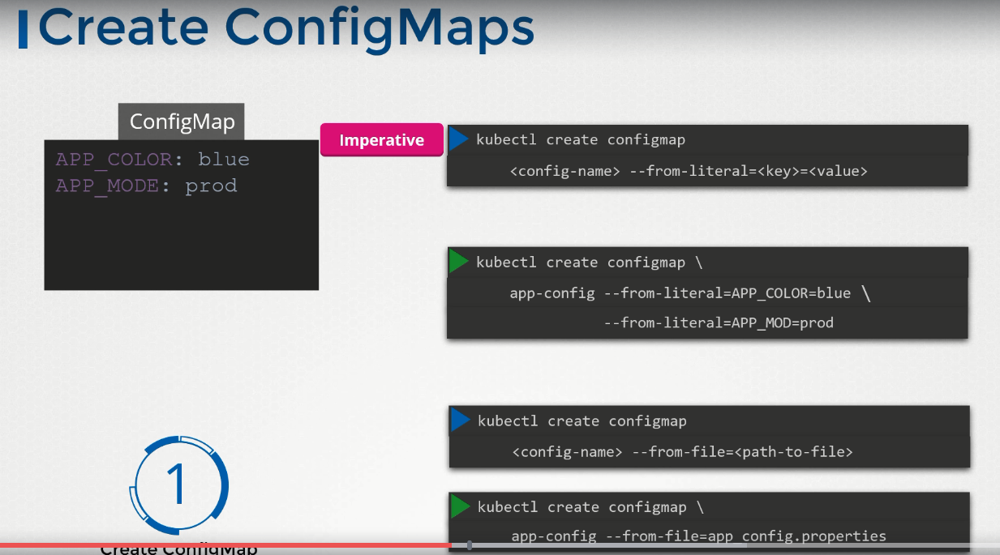

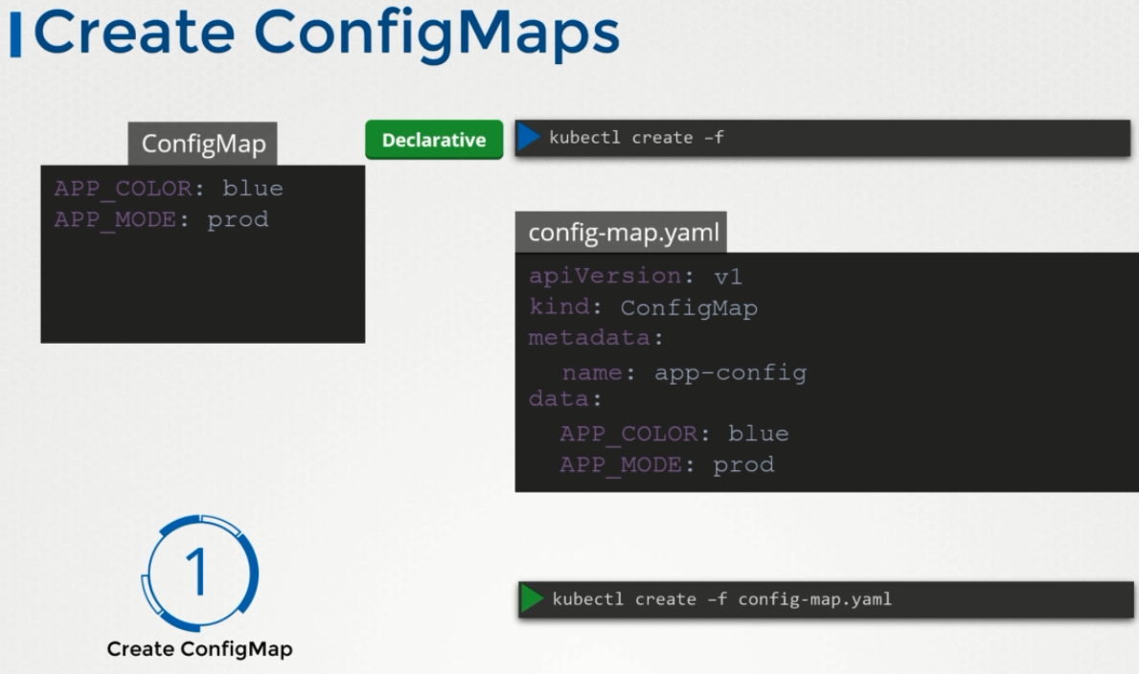

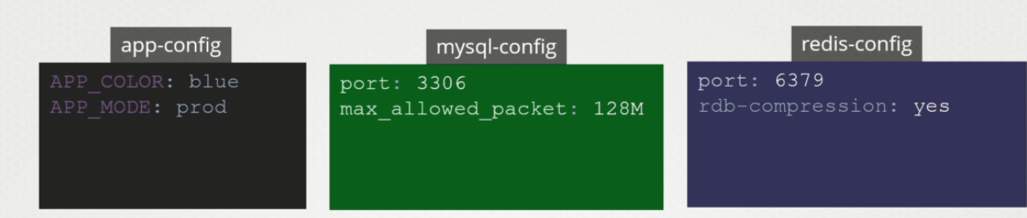

**Kubectl get configmaps -> cmd**

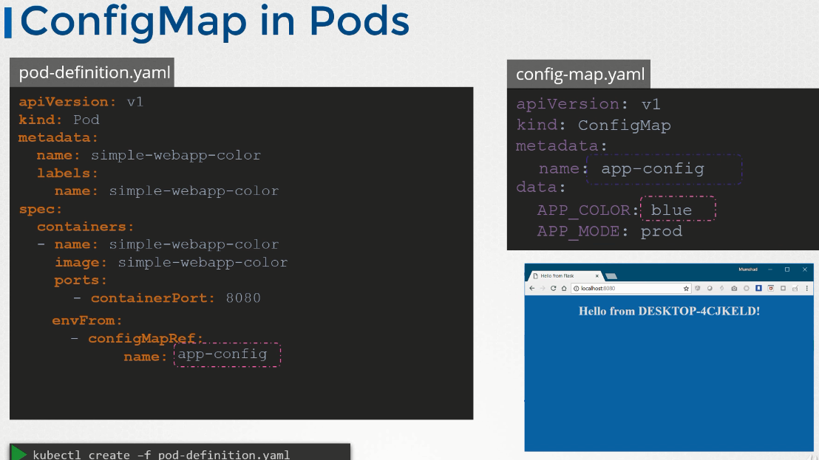

**Secrets:**

Secrets are used to store the sensitive informations, like password

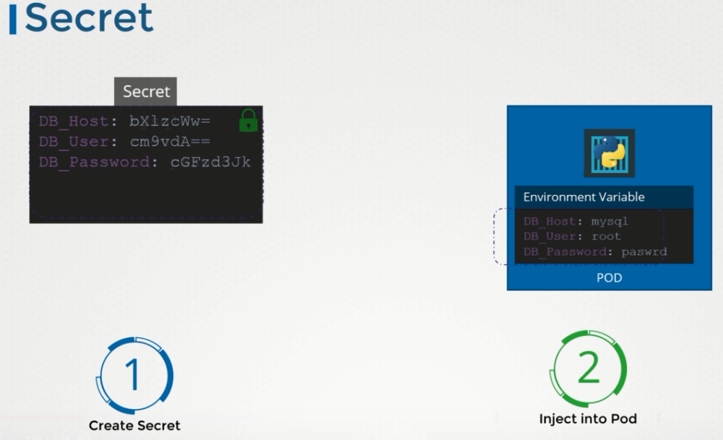

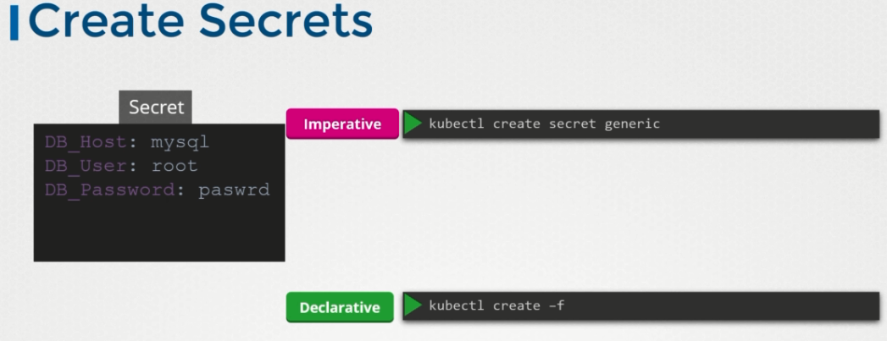

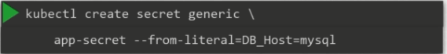

Kubectl create secret generic app-secret –from-literal=DB_HOST=mysql

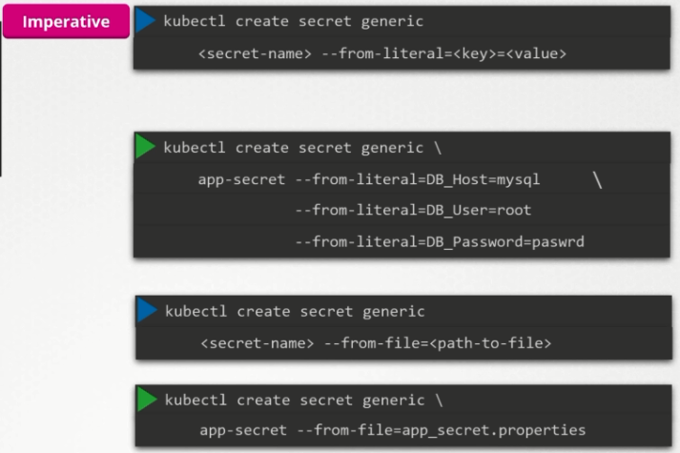

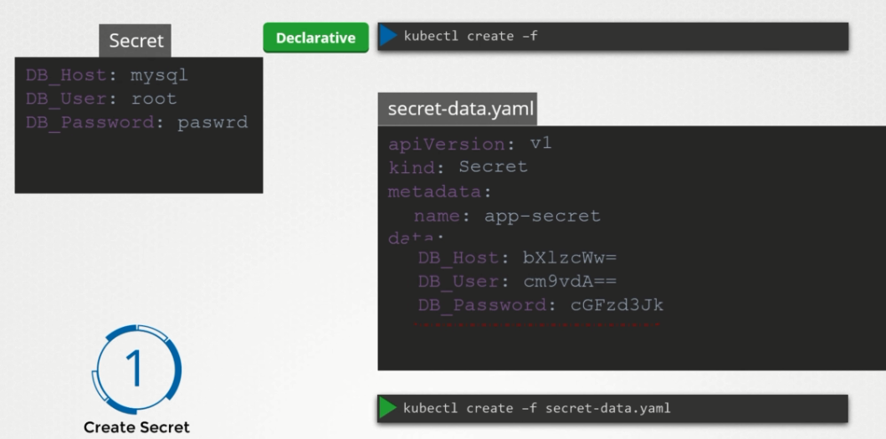

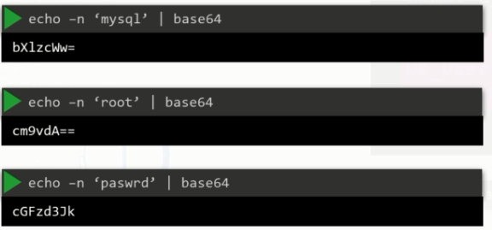

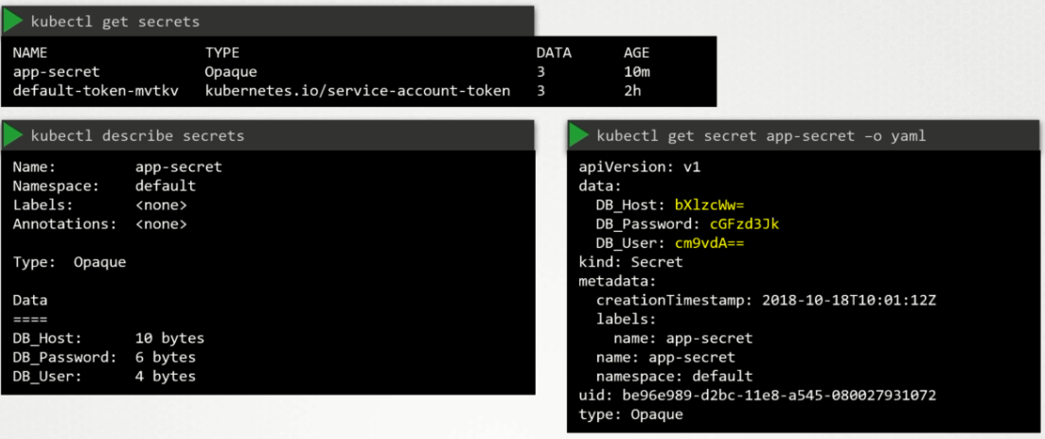

Decode the hash value

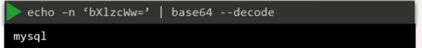

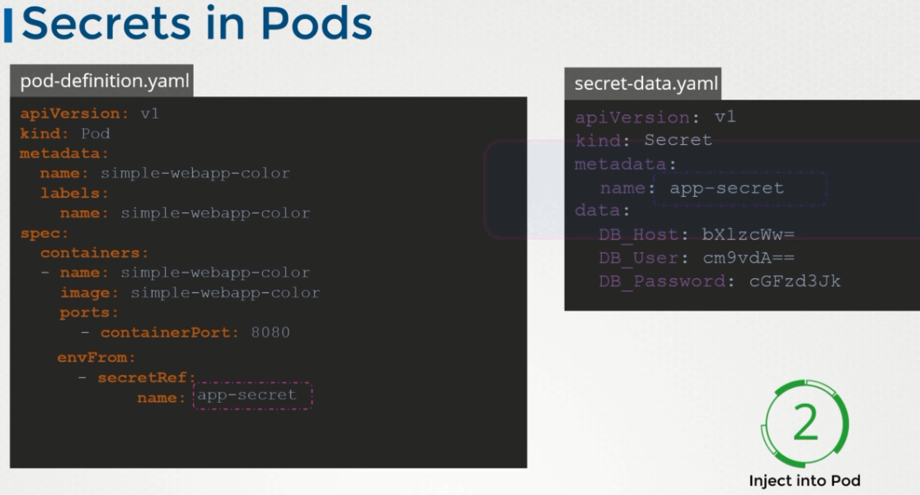

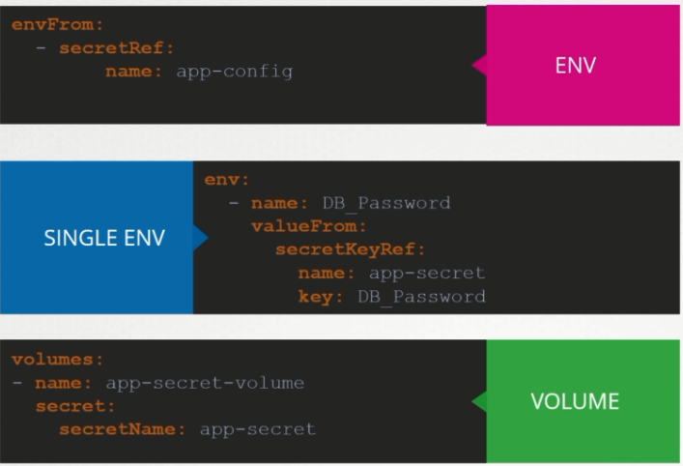

**Docker Security:**

**For a host -> root user || For a Docker container 🡪 root user**

**Security contexts**

**Pod level: Container level:**

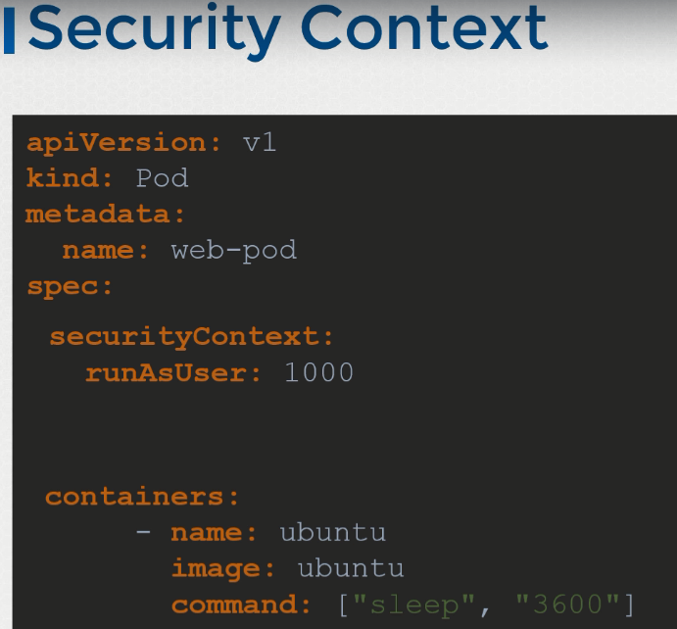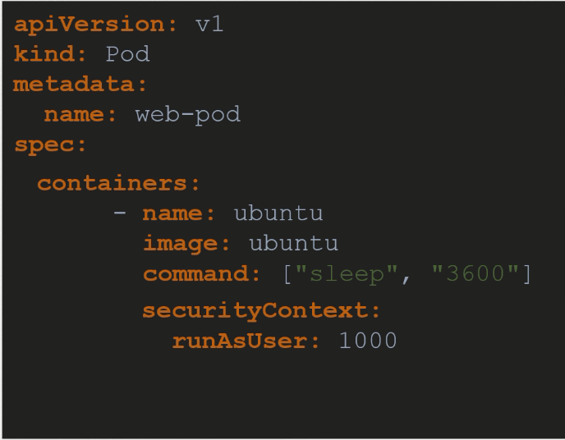

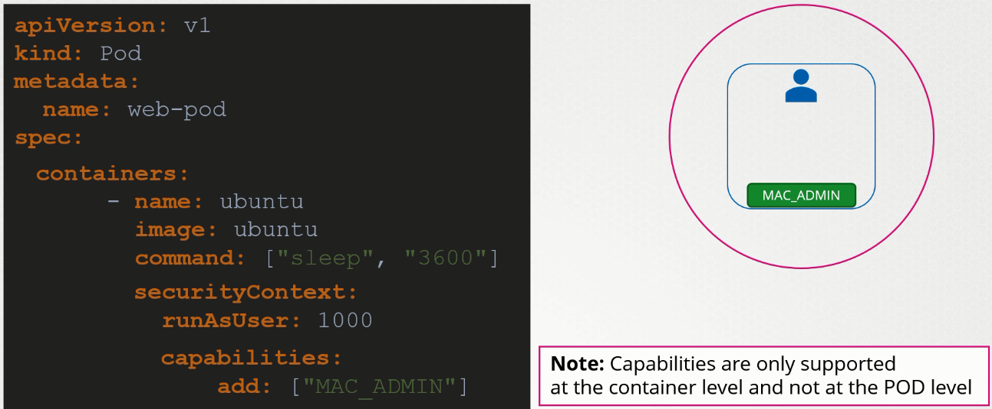

kubectl exec ubuntu-sleeper whoami

kubectl exec -it ubuntu-sleeper -- date -s '19 APR 2012 11:14:00'

**Service Accounts:**

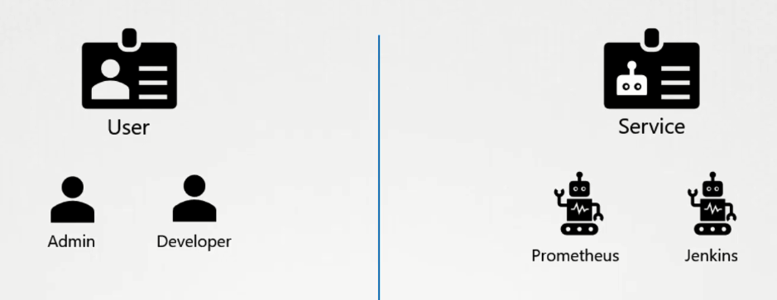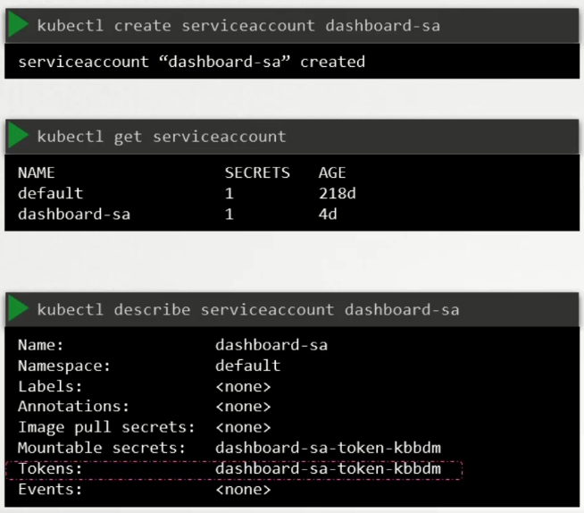

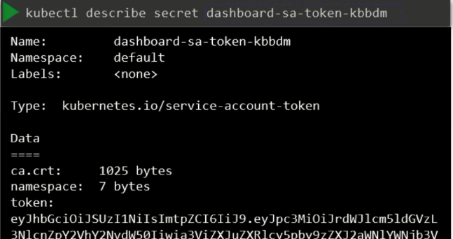



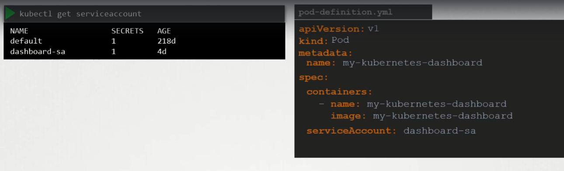

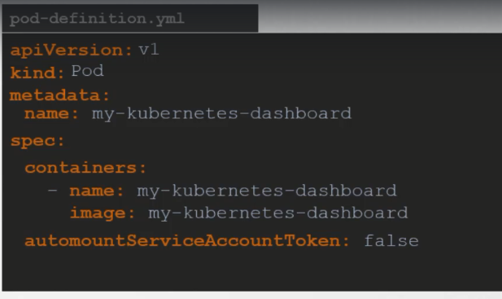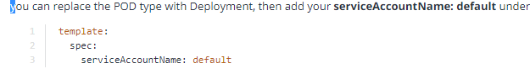

Resources Requirement:

Default: 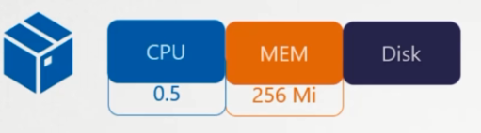

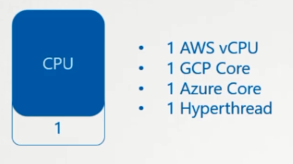 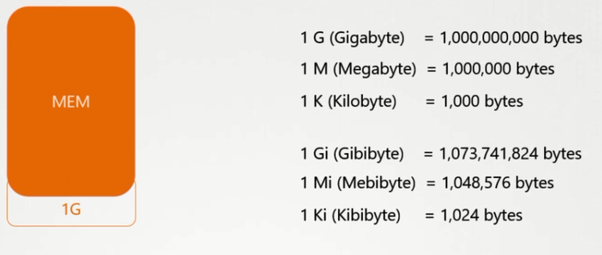

We can also set limit for resource usages in the pod

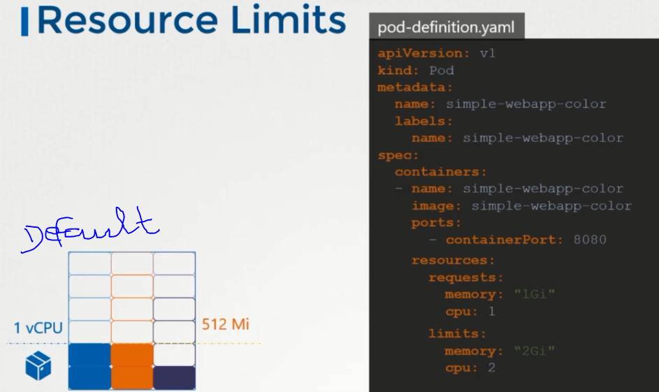

Container can use the more memory resources than its limit, But not CpU

Taints and Tolerants

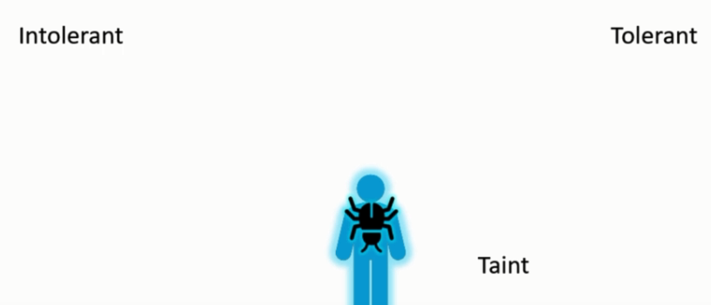

Imp 1. Taints on Node 2. Tolerant level

For some specific use cases , we nee dto deploy the pod on specific Nodes.

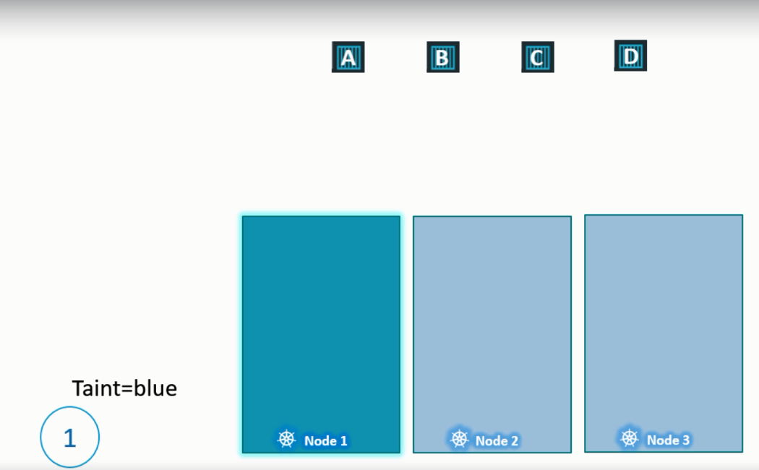 No unwanted pods ll be placed on Node1

Taints on set on Nodes , Tolerance set on Pods

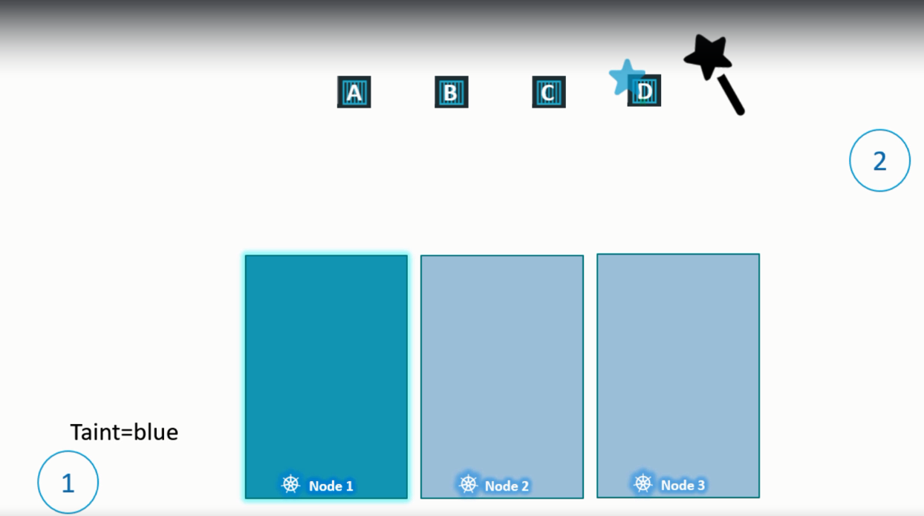 Add Tolerant to pod-D , so that it can deploy in Node1

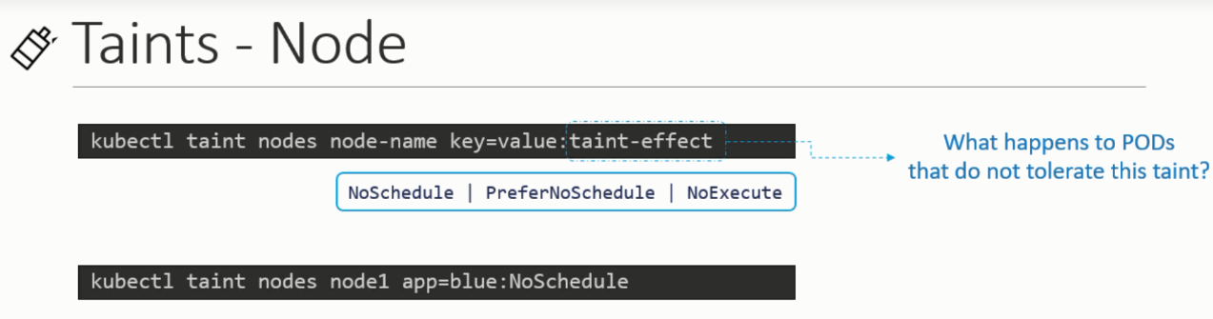



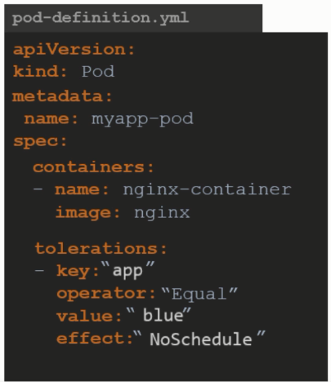

Initialy pod C deployed in the Node1, before adding taint to node1.

Pod C from Node1 was evicted because it cannot tolerate the newly added taint

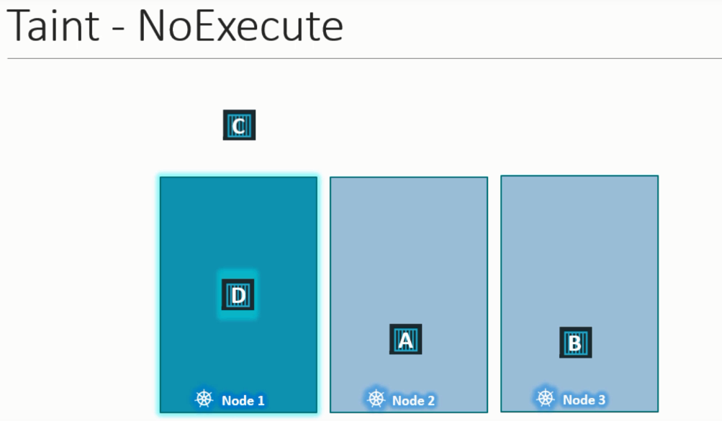

No Gurantee that pod D always deployed in Node1. It could be deployed in Node3.

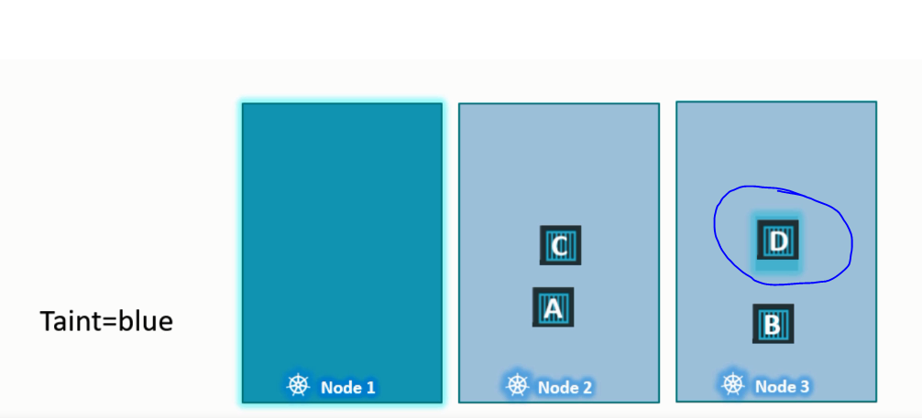

**BY default Master node is tainted to avoid deploying pod.**



**Node Selector**

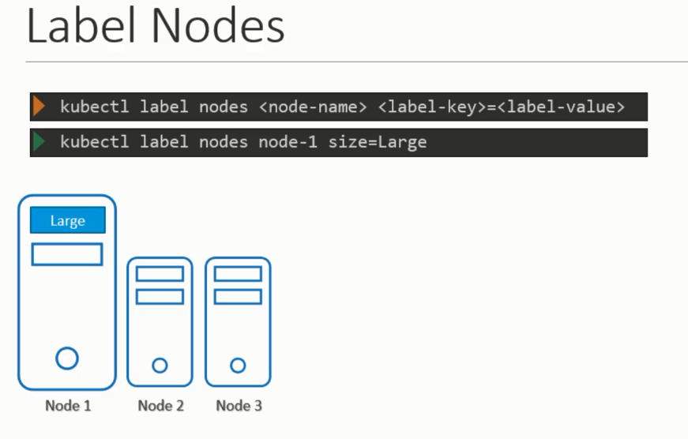 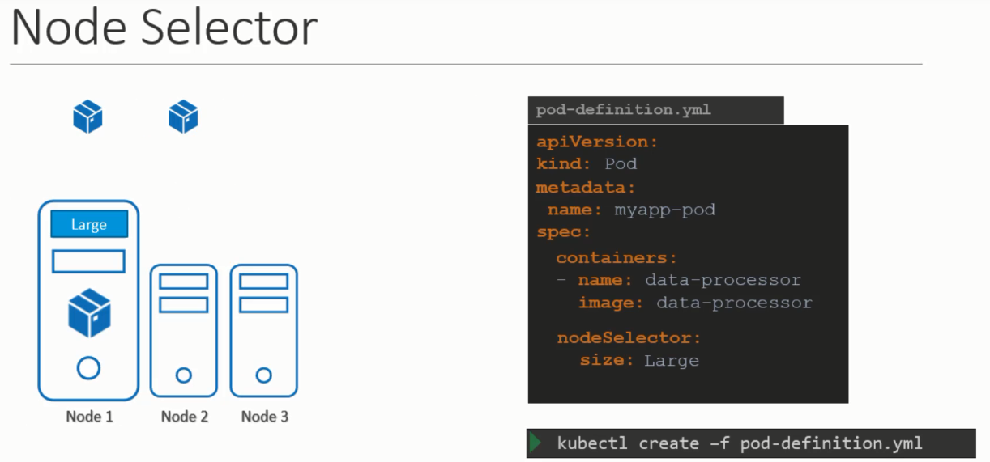

Some cases cannot be achieved by Node selector

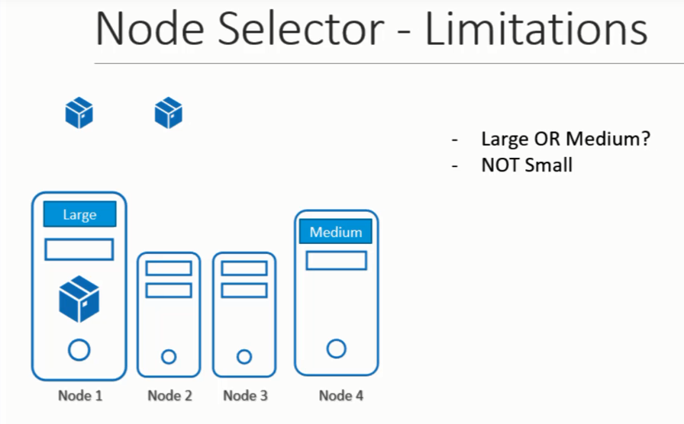**Advanced operators like – OR,AND,IN,NOTIN,EXISTS**

**Node affinity – To add extra operators so that pod is deployed on desired node**

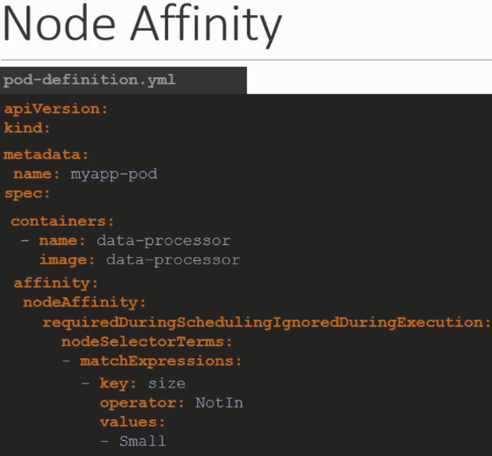

**Many operators are available , ex – In, NotIn, Exists**

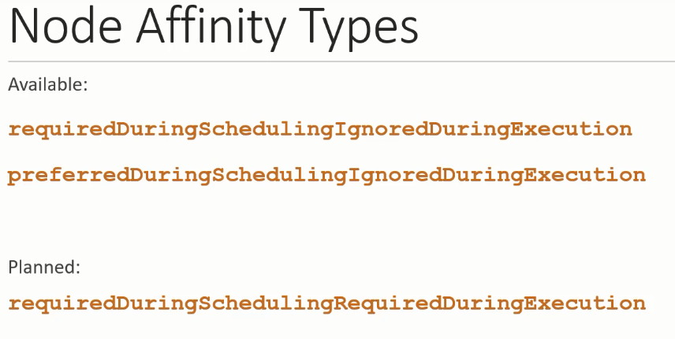

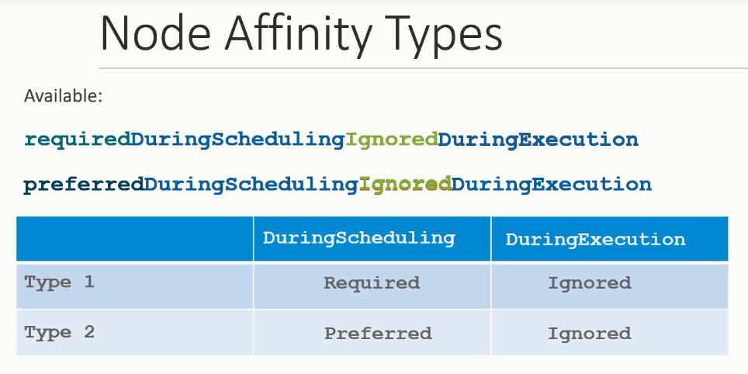

**A pod is running in a Node, in future the label of the Node is changed, in that case pod is continued to be run on the same Node.**

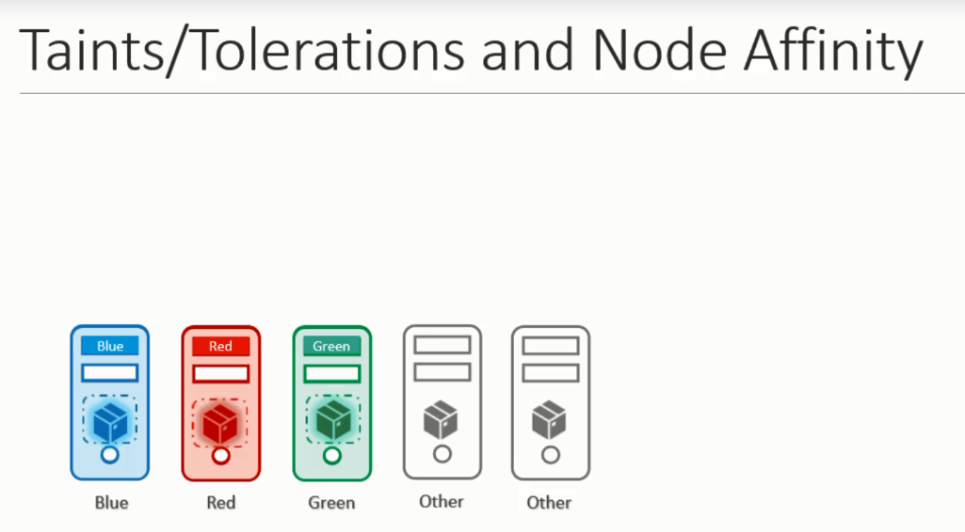

**Observability**

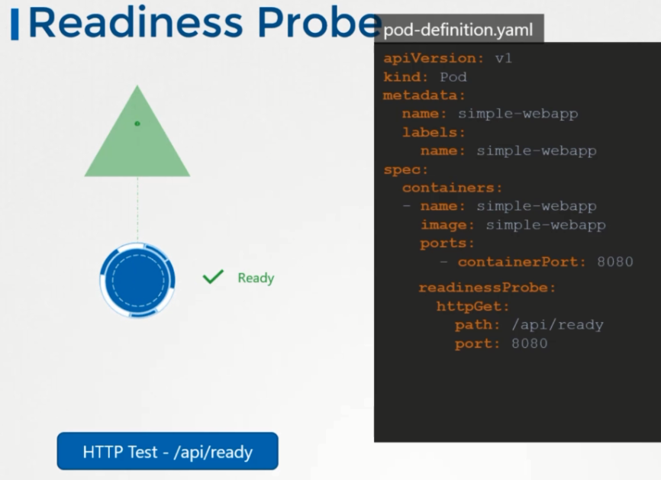

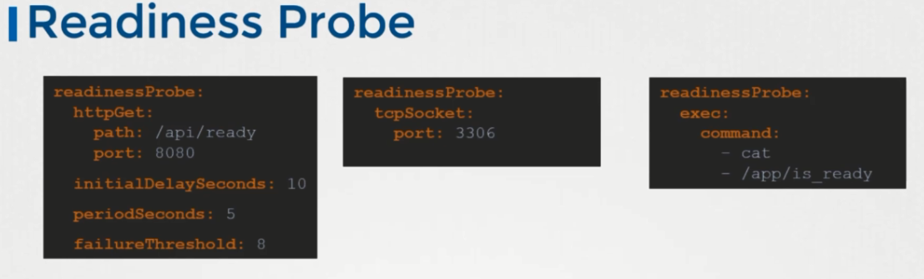



**Default threshold is 3 attempts,after that it declare it as fail. But we can increase threshold by failureThreshold option**

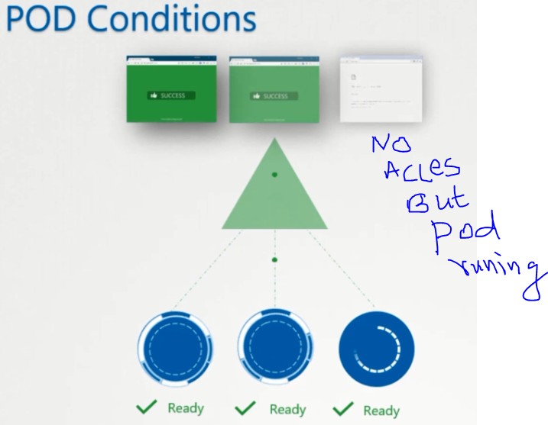

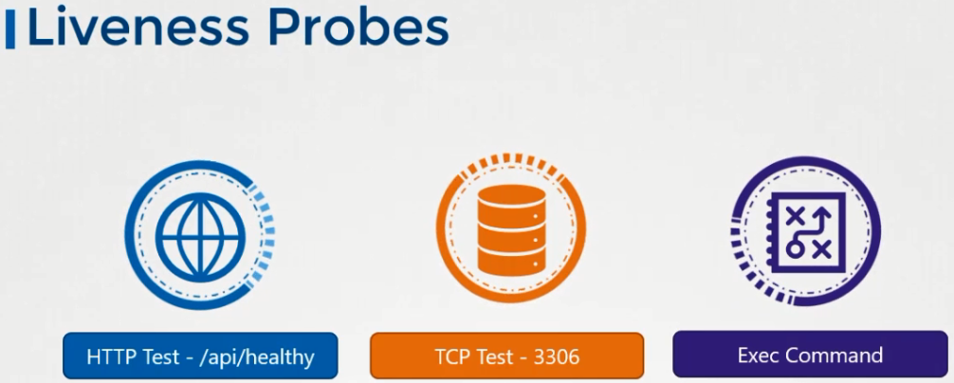

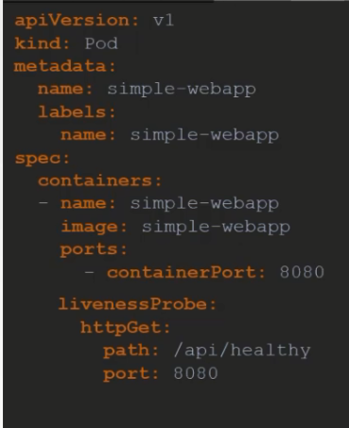

**Similar to readynessProbe**

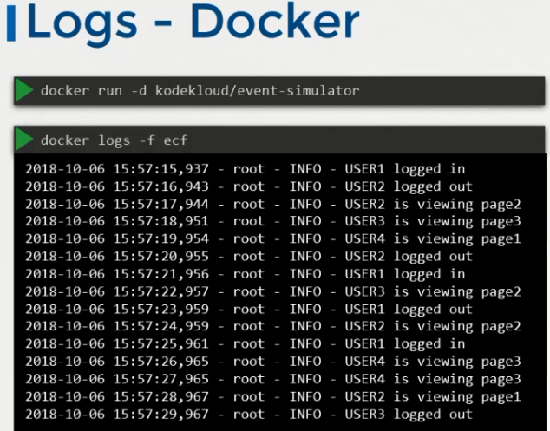

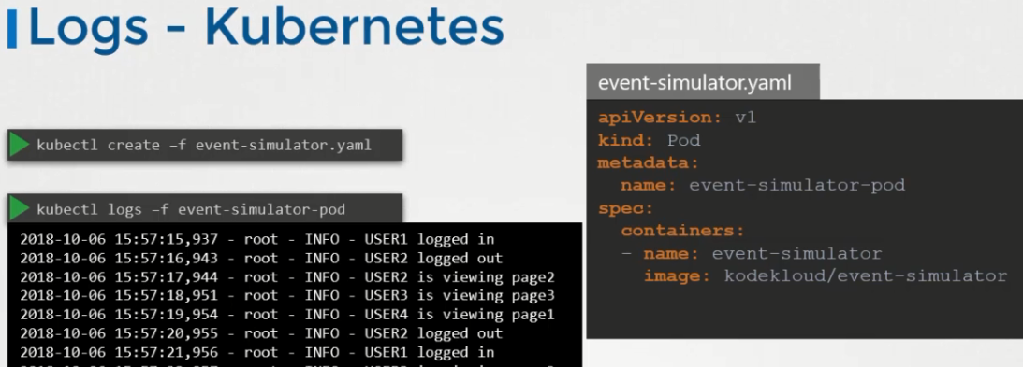

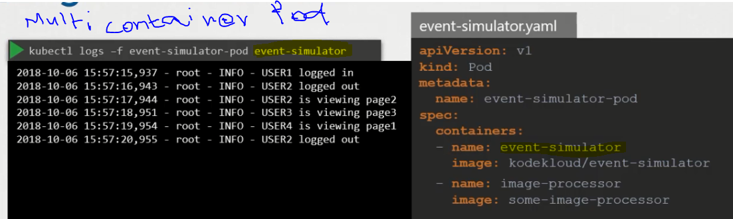

**Monitoring:** Node level, Pod level – collect metrics of Cpu,Ram,memory usages and give proper analytics

Many 3rd party open source solutions are available. Now we l look only Metrics Server

**Metrics-Server: In memory only**

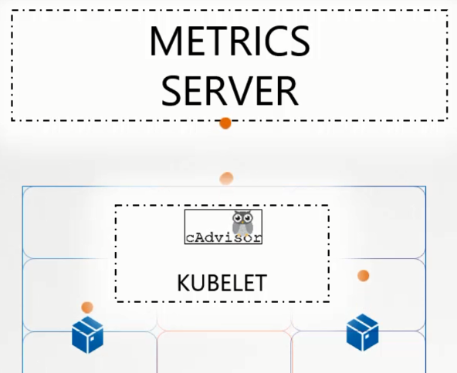

**After installing Metrics server in k8s cluster run the below command to see the metrics**

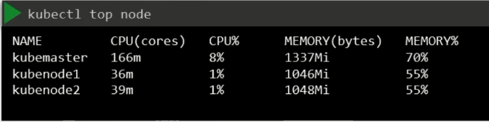

**Network and Services**

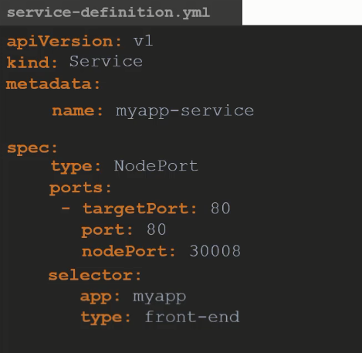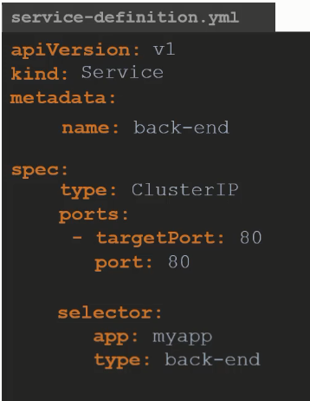

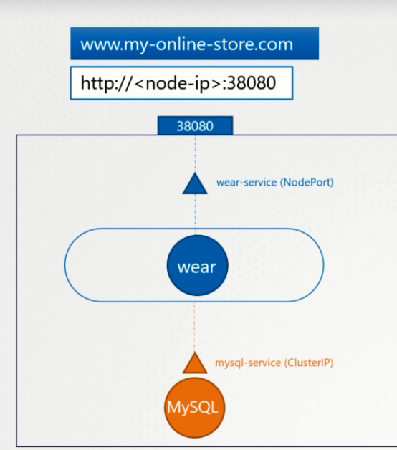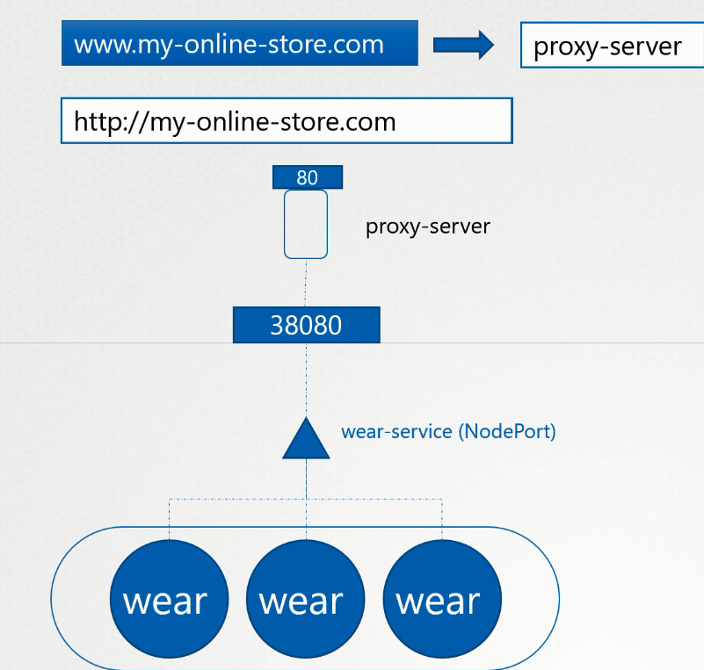

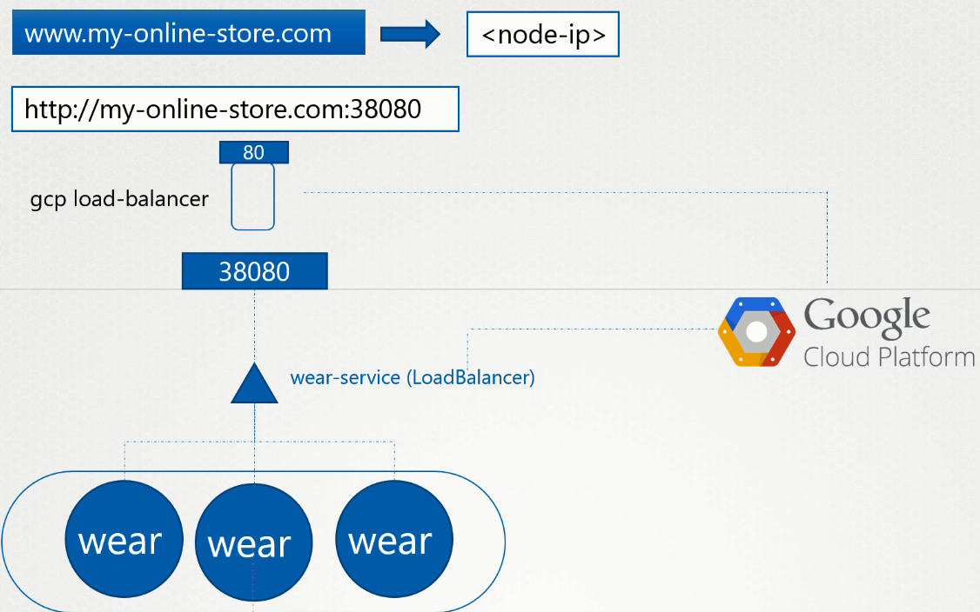 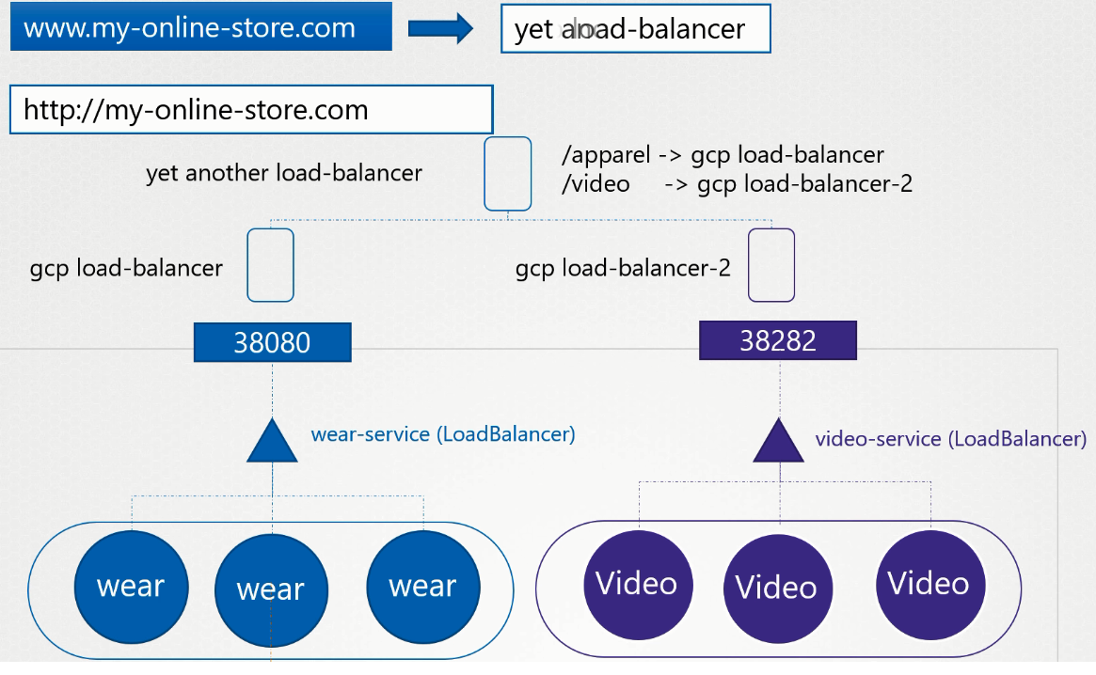

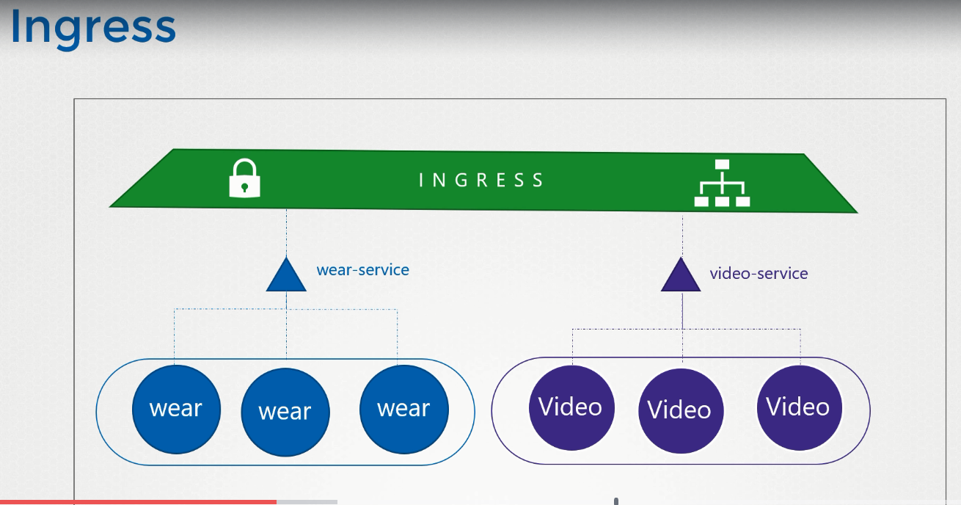

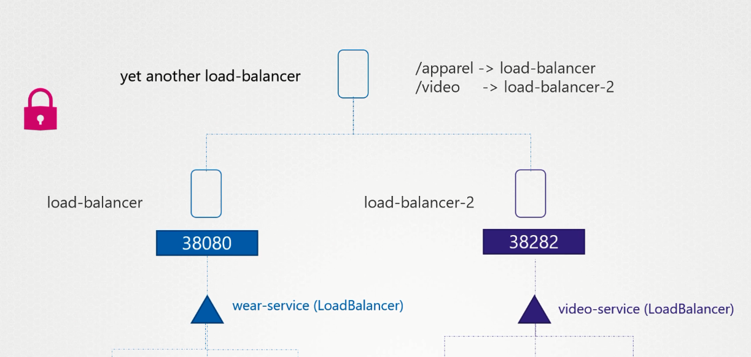

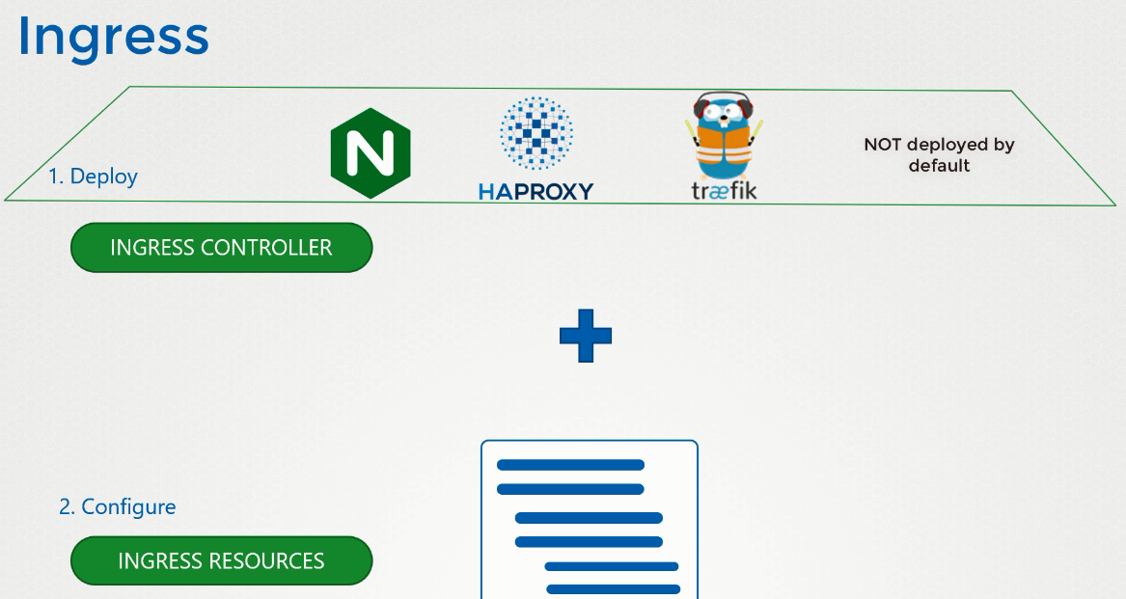

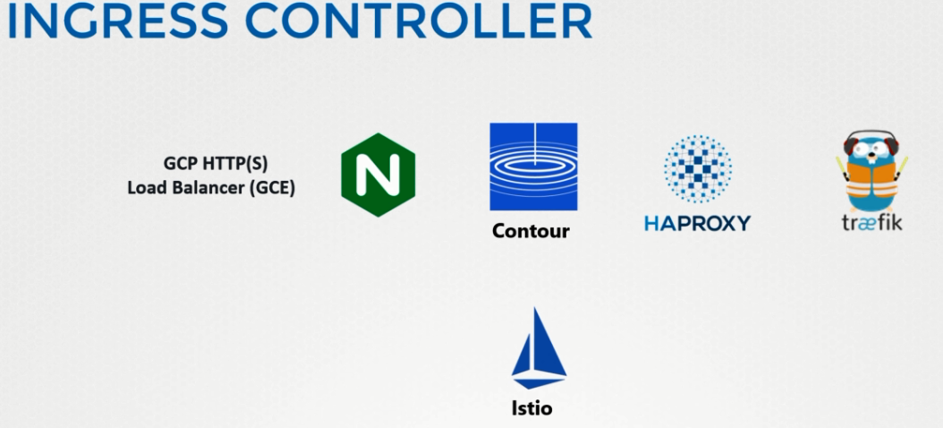

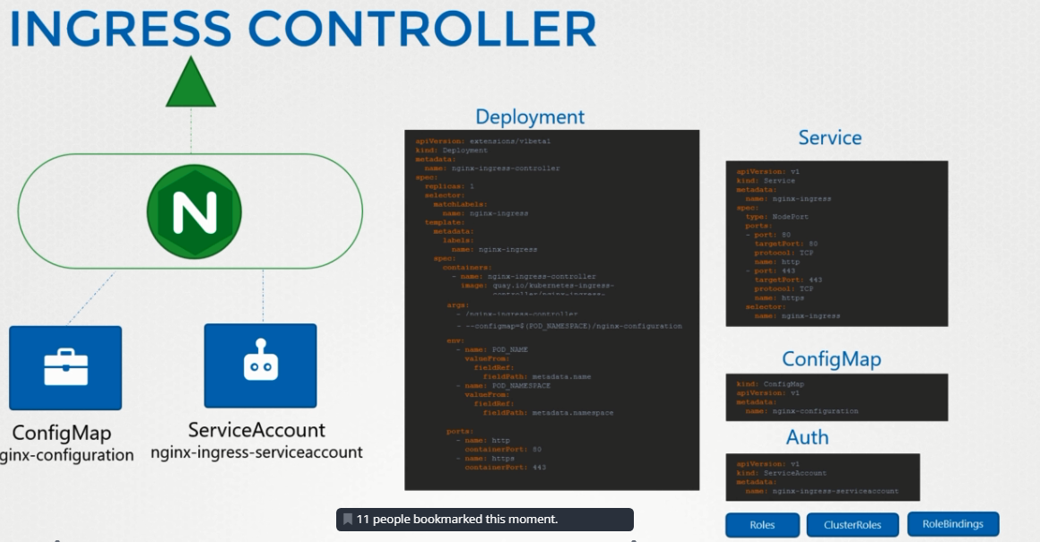

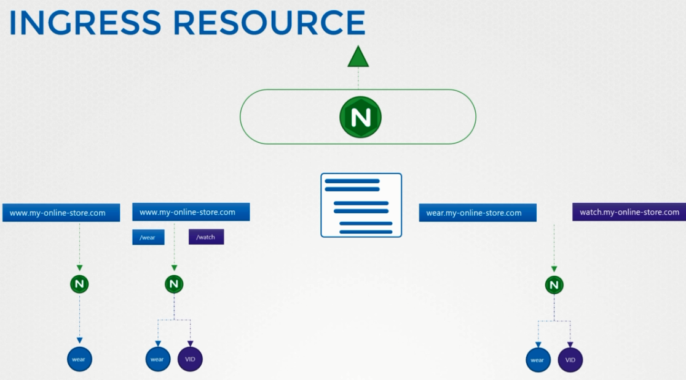

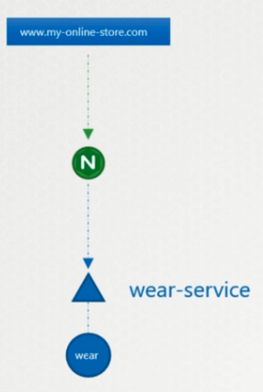 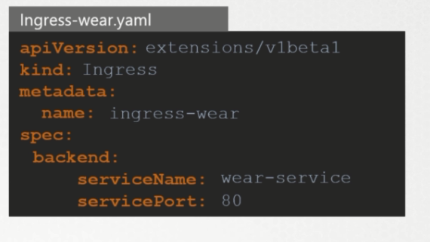

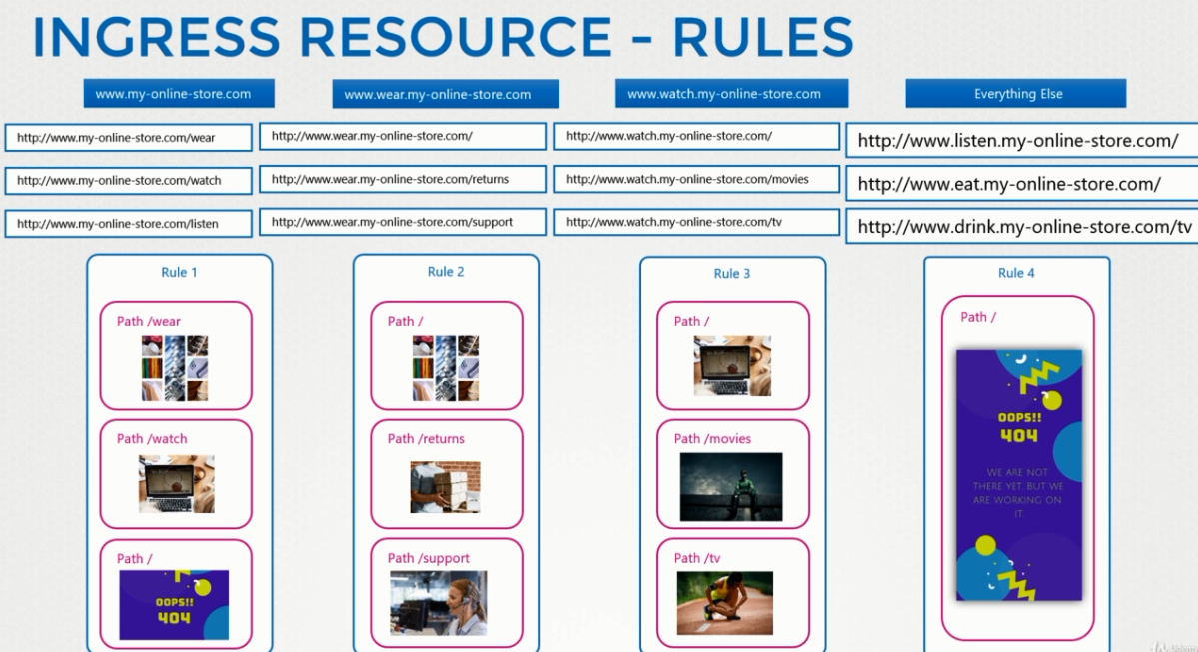

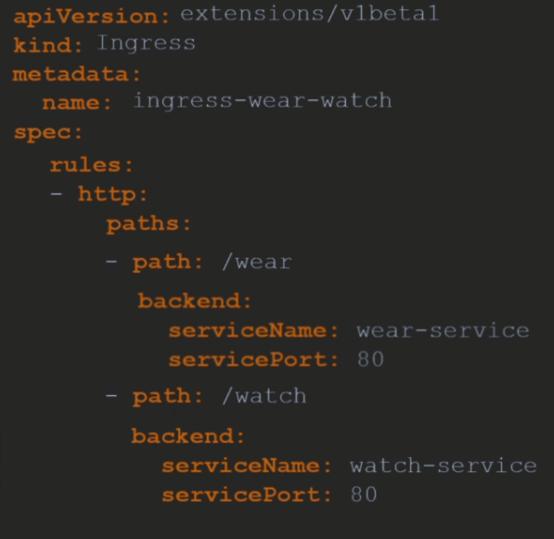 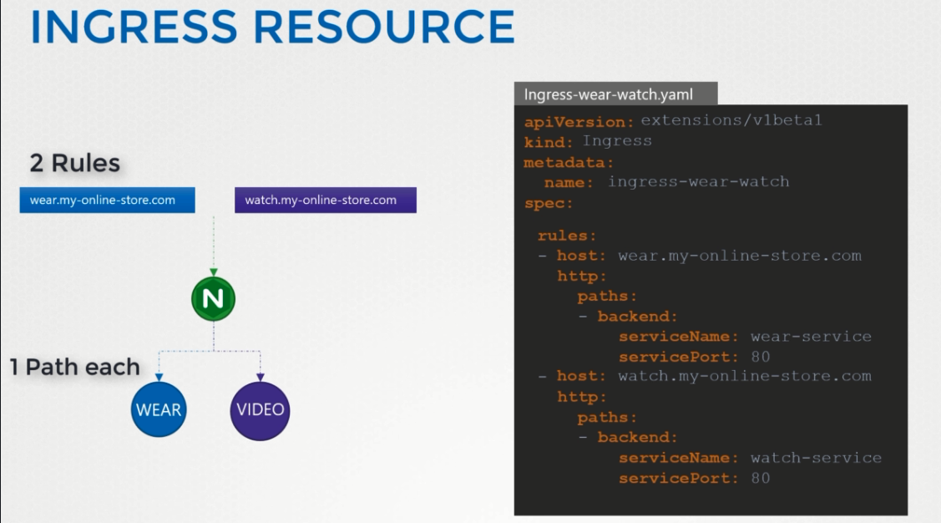

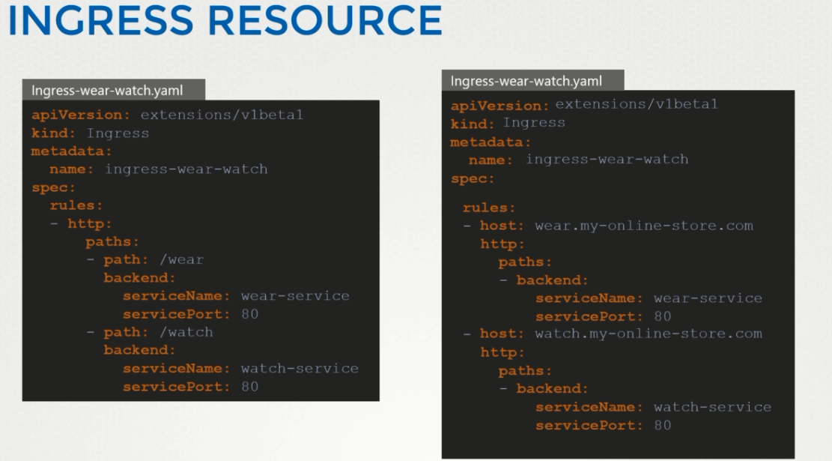

**By Default each pod can commincate with all pod. But some cases it should not be , that’s where we specify network policy where we set rules which pod can communicat with which pod**

